Computer Language Coding Concepts

Command Reference in a Diagram
The principle of command reference is explained in the article Command Reference. The current article demonstrates the expression of it in a diagram.

A command reference is displayed in a diagram as a diamond or square connected to another diamond or square with a solid line.



It does not matter whether it is squares or diamonds, because the only difference between a square and a diamond, is that a square can not be executed and a diamond can.



Direction of the line must be indicated with an access mark, unless the line is going outward, out of something:

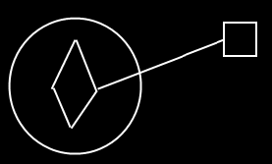

See also: Command Reference, Commands

Author & Copyright: Jan-Joost van Zon Date: May 25, 2008 – August 13, 2008 Location: Oosterhout, The Netherlands Status: Finished

